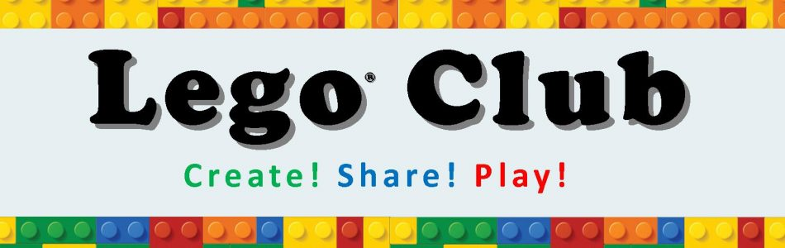

1st and 3rd Thursdays, beginning Oct 18th
3:35 pm – 4:25 pm
SBMS Room 323
Parent permission slip required,
Print below.

SBMS Lego Club 2018-2019
Dear Parents,
Thank you for your interest in Lego Club. The purpose of the club is to facilitate friendships around common interests. In addition, students will learn collaborative play, following directions, and facilitate creativity. If this sounds like something your student is interested in, we would love to have them!
Lego club will be held on the 1st and 3rd Thursdays most months beginning Oct 18th in room 323 with Mrs. Easto. Lego Club will dismiss at 4:25 pm. Students can be picked up in the front of the school or can ride the late bus.

A few questions:
Student Name: __________________________________________________
Homeroom Teacher: _____________________________________________
Parent Name(s): _________________________________________________
Contact number: ________________________________________________
Email:_________________________________________________________

My student will:
_____ be picked up
_____ ride the bus

Any food allergies or foods to do not want them to have:
________________________________________________________________

Semester 1 Lego Club dates: 10/18, 11/1, 11/15, 12/6
Semester 2 Lego Club dates: 1/17, 2/7, 2/21, 3/7, 3/21, 4/4, 5/2

